1. A certain computer holds floating point binary numbers using an 8 bit mantissa and a 4-bit exponent.

(a) Convert the following numbers from floating point binary to denary.

(i) 0.1011100 0011 [2]

(ii) 1.0101101 0101 [2]

(b) Convert the following numbers from denary to normalised floating point binary.

(i) 13.25 [2]

(ii) -13.25 [2]

2. (a) What is the purpose of normalising a floating point binary number? [2]

(b) What is the most negative number that can be held in an 8-bit mantissa and a 4-bit exponent, expressed as a decimal number? [2]

3. Numbers are stored in a computer system using fixed point binary with 5 places before and 7 places after the binary point.

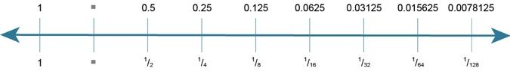

(a) What is the maximum value that can be held, to the nearest whole number? [1]

(b) Explain what is meant by **underflow**. Describe a situation in which it could occur. [2]

Total 15 marks